Lab Exercise 2– Terraform AWS Provider and IAM User Setting

Prerequisites: Terraform Installed: Make sure you have Terraform installed on your machine. Follow the official installation guide if needed.

AWS Credentials: Ensure you have AWS credentials (Access Key ID and Secret Access Key) configured. You can set them up using the AWS CLI or by setting environment variables.

1. Create a new Directory

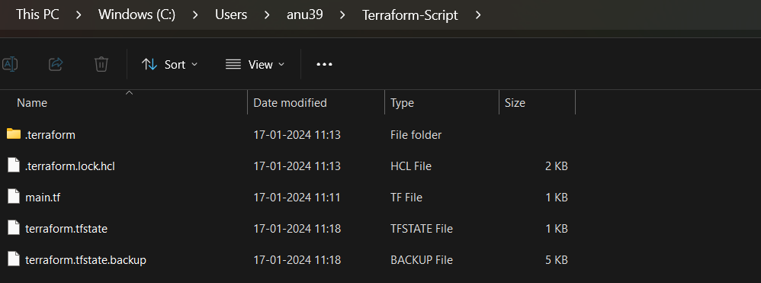

1. Create IAM User

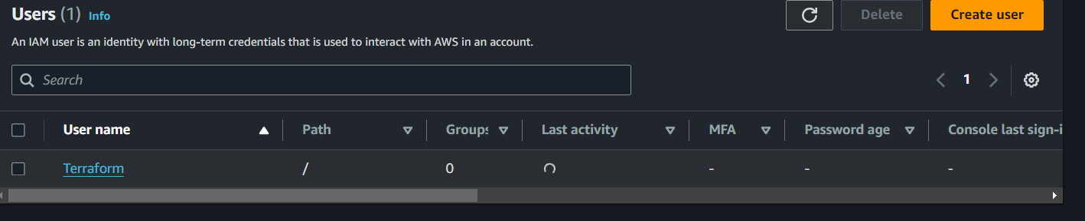

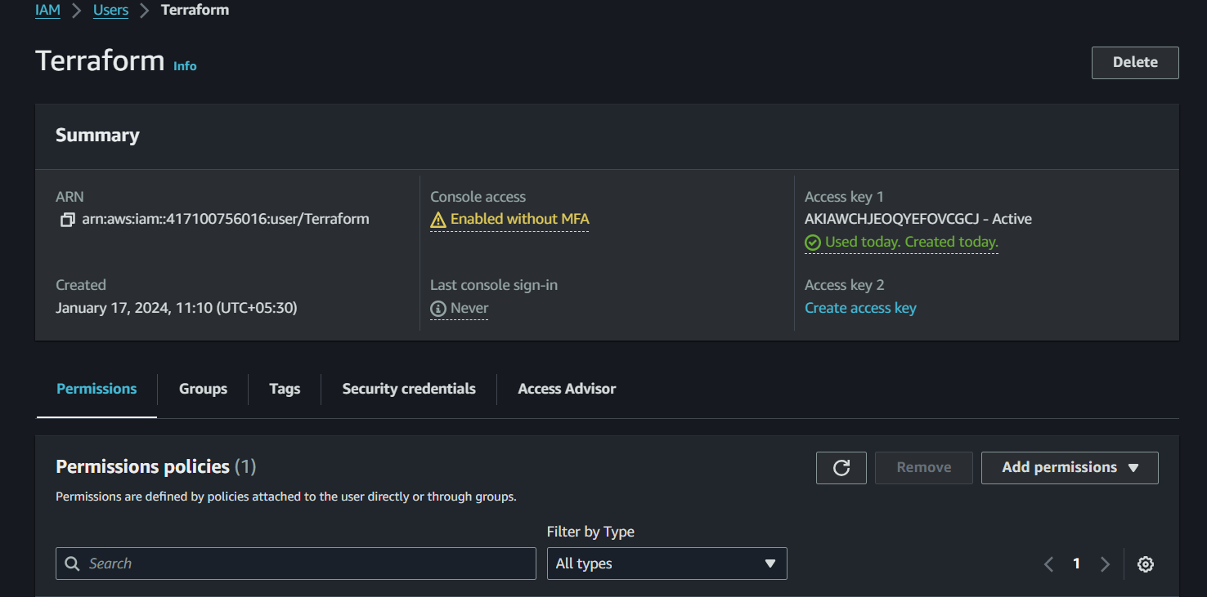

1. Create Terraform Configuration File (main.tf)

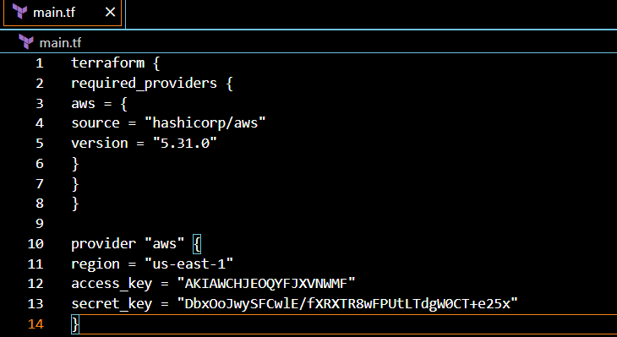

1. Initialize Terraform:

